In God We Trust
January 28th, 2021

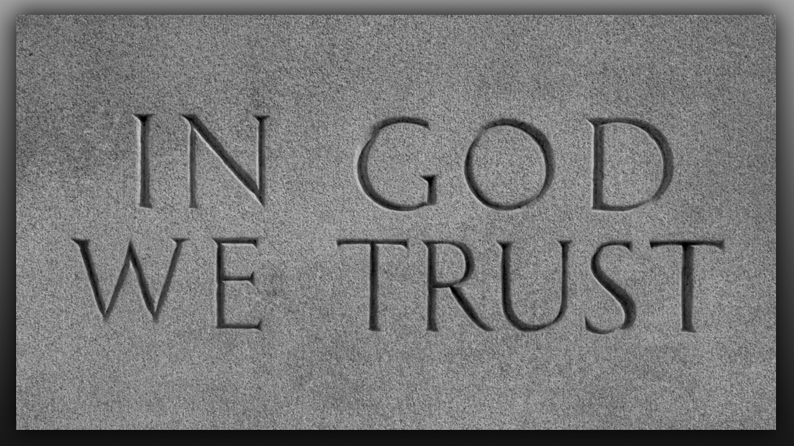
My Beloved family, sweet souls that dwell in the Heart of Jesus, the peace of the Lord be with you all. Be confident of this dear one, your prayers for this nation are being answered. You all are aware of my many faults and flaws because I have shared them with you. But in the process of that sharing I have also given the enemy a view of my weaknesses and they have capitalized on that cursing me at my weakest points.

But the Lord has said that where I am weakest, He is strongest. So, when I open myself to the enemy, I am counting on the Lord’s strength to help me resist and grow in virtue. But with our nation and the very real war we are engaged in, things must be done differently. I can reveal my inner workings to you knowing that the enemy will take note and attack accordingly, but in this war between good and evil, the president, and those around him, cannot open to you what they are doing.

You see the Lord told me, that China has come very close to taking over our country. Do you realize how serious that is? Does that sound incomprehensible to you? Well, let me assure you, there is much that has been kept from you so that you will not panic and make the country weak. We must remain united and strong as a nation, and because of that there will be many tactics of spreading false information.

This information, even from the best of sources, which I count Simon Parkes and Robert David Steele, and Dr. Charlie Ward, even from them, and Lin Wood, there will be times when we are told one thing and another is done, or there is a delay. So, we must get our information from God and He has told me that President Trump is going to triumph in all of this. Jesus told us to look at the record of the man’s life. Look at his life.

He had absolutely no need to get involved in politics if you count money and success as everything. When he took on this job, he laid the groundwork very, very carefully. He studied the dynamics at work, he even prepared the nation by allowing the filming of his day in and day out dealings in the world. That show, The Apprentice, gave the world a look into what kind of man he is, and how he handles things. And skills he had were only enhanced when he gave his life to Christ, which the Lord has assured me, he did.

The Lord knew what He was doing, The Lord knew what He was doing. He knew that Donald is not a quitter, He knew that Donald would lay down his life for the noble cause of restoring the Republic of America and routing out the formerly controlling Satanic system. Donald knew it could cost him his life and the lives of those he loved most. But he took it on anyway. And contrary to the lying media, and all superficial appearances, he is still in the saddle, still working to restore America on a clean and fresh foundation. Not one fashioned after the Masonic model and symbolism in Washington, being demonic, from the layout of the buildings to the artwork to the Washington monument, which is a phallic symbol that also stands before the Vatican, who are also players in this drama to control the world and take away our freedoms. Freemasons laid the cornerstone of the Washington Monument on July 4th, 1848 using George Washington's Masonic apron, gavel, and other Masonic regalia. So, you see the very foundations and layout of DC is Satanic.

So, in order to overthrow the deep cancers of Satanism in this country, and all the different administrations, from the littlest policeman to the highest office, of President in order for this to happen an extraordinary amount of planning and carefully determined timing, much like a chess game, was and is necessary. The black hats make a move, and the white hats respond, or more properly the white hats set up the black hats to make a move and truly are in control of what they will do next. I do not think many of you know that they have been holding a gun to Donald's head, not to kill his children, but to set off hidden nukes in major cities. So, you see, what is taking place is anything but cut and dried. I have seen these in the spirit, the one in particular was in an alley in New York City. It looked like a large, covered dumpster, but when it began to swing into action and tilt and open, there was a nuclear missile inside. And the one I saw was launched straight up into the air in the confines of this alley.

The other thing most people do not recognize is that China has troupes at our Northern and Southern border. They are waiting for chaos in America so they can attack when we are at our weakest. So, President Trump has to work within the confines of these two great threats. That means he cannot do things overtly that will set off the enemy's anarchists who have been trained and equipped to destroy cities, cause all kinds of havoc, in the nation and begin a civil war.

I am sharing all this with you so that you will understand, indeed much is going on behind the scenes, but it must remain hidden in order to prevent a civil war which would weaken us and open the door for China to invade. And please rest assured, President Trump won the election by a landslide, even winning California. The evidence is online and overwhelming. I am telling you all of this to know that Our true President will Triumph. What is needed now is a very calm demeanor from all of us, no demonstrations because that would enable the black hats to wreak havoc.

Prayer is the weapon of choice. Even as the Scripture says, We do not wrestle against flesh and blood, but against the rulers, against the authorities, against the cosmic powers over this present darkness, against the spiritual forces of evil in the heavenly places. Therefore, take up the whole armor of God, that you may be able to withstand in the evil day, and having done all, to stand firm. That is Ephesians 6:12-13. This is the crux of the situation and this is the battle. And this is where the battle will be won, in prayer.

Contrition for our sins, a deep and sincere repentance for both our personal sins and our national sins, is what will move the Hand of God.

Lord, please speak to us.

Jesus began, "Beloved, all that you have said is true, yet I want this war to be won in the Spirit, through prayer. You have made good points but do not get involved in the drama other than to acknowledge progress is being made. You are correct in seeing the internet/cell phone blackouts as indicators of covert action by the white hats. These are sign posts for you dear ones that progress is indeed being made, despite all appearances to the contrary. There are many more, such as errors on the set and filming of the inauguration which was a total sham and not binding. It is all a game to keep the peace while the really powerful moves are invisible to the public. Someday there will be a great film made of these events, but for now they must remain hidden.

“Listen My dear ones, pray for your soldiers, pray for the elected officials and those surrounding your president, who are working for freedom. Pray for the eyes of the blind to be opened, and that people's hearts would be moved to pray and support what is going on behind the scenes. Pray for your president's safety, as well as that of his loved ones. Pray for those who are channels of correct information, such as those you have mentioned. Pray for wisdom and courage for all involved.

“I have a plan; I am with Donald Trump and his administration. I am calling on you to pray behind My plan and stand in the gap when you hear of violent outbursts, pray for the safety of the innocent caught in the line of fire, pray that evil will be exposed and disarmed before it does damage. Then when you have done all, STAND. Stand in faith and rest in Me. Draw close to Me beloved ones and I will give you rest.

“Come deeper into the waters of cleansing and equipping to move forward in your own personal missions. You accumulate much contamination from the world each day, and especially now when evil is at its zenith. You have an important part to play in the coming days, but you will not be ready if you spend time on the internet, surfing and looking around, following every new item of interest. I will give you confirmations that your prayers are working, but I want the weight of your time spent in prayer not alternative news. I know Clare this is hard for you, but you have taken a step back and away from constant curiosity, and you must continue to force yourself to deny every impulse to check something out. You are in a good place now My Dove, hold your ground.

“Know My People, this war will be won by prayer. You are partnering with Me in your prayer time, that justice may be done. There is still much undecided, such as the timing of the Rapture but suffice it to say that as long as there is relative peace in your country, it is on hold. As you know, I have shown you that when nuclear war breaks out, you are at the brink. Yet, in Heaven, we are all prepared and My heart is still to dance with you and bring you great comfort for all your labors. Yes, these times are laborious, but My yoke is easy, My burden light and I long to be close to My Bride. This time of refreshing is just as important as prayer and repentance.

“Know that I delight in your presence My Brides, draw close to Me, comfort Me, rest in Me and find your delight in our times of refreshing together.”

And that was the end of His message. And lately He has been very much wanting to dance and just be in each other’s presence. He is spent quite a bit of time dancing with me during my worship time. I would see Him approach me and take my hand and begin to dance with me on the dance floor. And it was so pure and innocent and yet there was so much joy emanating from both of our hearts that I was truly refreshed. I know that He genuinely wants this for you, too. So please, give Him time, give Him that special time when you are not interrupted so He can invite you onto the dance floor in Heaven and regenerate you and give you hope, stamina and be bathed in His sweet love for the strength that you need to remain sweet and loving while so many are stirred to bitterness and rancor. He is calling upon us to be loving, brotherly love, humility, forgiving. He does not want us involved in the rancor, and the anger that comes forth from these demonstrations. And we will win this war through prayer, but be sure to give Him time, intimate time, where you can just rest in His presence.

